Grade 7 Accelerated · Unit 4 · Assessment  Solving Problems with Rational Numbers  Form B · 29 points ANSWER KEY | Name  Date  Period

Show your work. One point for each lettered part.
Operations in Scientific Notation 12 points MA.8.NSO.1.5
If an earlier part is wrong, a later part still earns its point when the right operation is applied to your own earlier answer — but only if that work is on the page.
1. Add or subtract. Write each answer in scientific notation.
a. 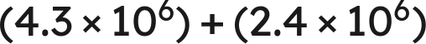 1 pt

Same power: add the coefficients.
b. 1 pt
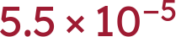
c. 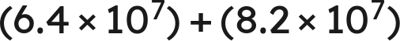 1 pt

 is the value; 14.6 is not less than 10, so it is not the answer.
d. 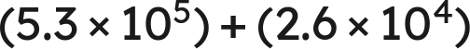 1 pt

.
Scoring: a 1 · b 1 · c 1 · d 1 = 4 points.

2. Multiply or divide. Write each answer in scientific notation.
a. 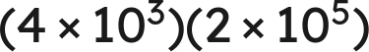 1 pt

b. 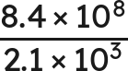 1 pt

c. 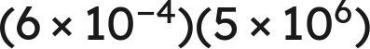 1 pt

 is not finished.
d. 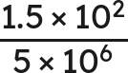 1 pt
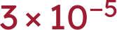
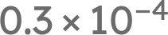 is not finished either.
Scoring: a 1 · b 1 · c 1 · d 1 = 4 points.

3. Which is the value of 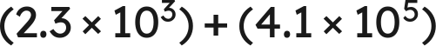 ? 1 pt
○ A. 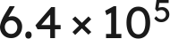
● B. 
○ C. 
○ D. 
B
Scoring: 1 point.

4. Select ALL of the expressions whose value is 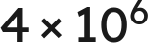. 1 pt
☒ A. 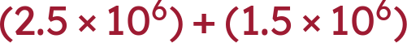
☐ B. 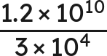
☒ C. 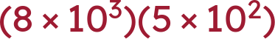
☒ D. 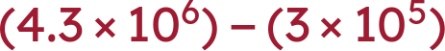
☒ E. 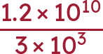
☐ F. 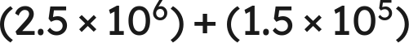
A, C, D and E
C gives , which is 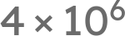 once it is finished. All four correct and nothing else for the point.
Scoring: 1 point.

5. Devon writes . Name the two mistakes he made, and give the correct sum. 1 pt
He added the coefficients without first writing both numbers over the same power of ten, and he added the exponents. The correct sum is .
Both mistakes must be named for the point; one of the two is half the item. .
Scoring: 1 point.

6. A number is multiplied by 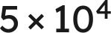 and the product is 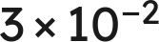. What was the number? Write your answer in scientific notation. 1 pt
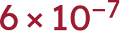
TRANSFER ITEM — not on the practice test. Same benchmark, a surface nobody rehearsed. 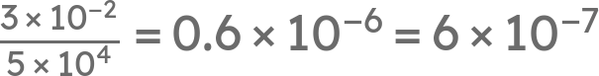. Working a product backwards across a sign change appears on no review and in no question bank; the point is for the finished form, so 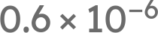 alone does not earn it.
Scoring: 1 point.

Real-World Problems in Scientific Notation 4 points MA.8.NSO.1.6
If an earlier part is wrong, a later part still earns its point when the right operation is applied to your own earlier answer — but only if that work is on the page.
7. Solve. Write each answer in scientific notation. Do not round.
a. A rectangular plate measures 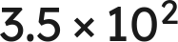 mm by 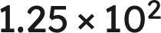 mm. Find its area. 1 pt
 square millimeters
Multiply the coefficients and add the exponents: 3.5 · 1.25 = 4.375, and .
b. A vehicle travels 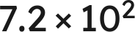 km in 8 hours. Find its average speed. 1 pt
 km/h
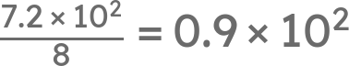, which is not finished: 0.9 is less than 1.
Scoring: a 1 · b 1 = 2 points.

8. Solve. Write each answer in scientific notation. Do not round.
a. Two lengths are measured: 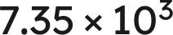 mm and 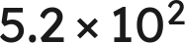 mm. Find their sum. 1 pt
 mm
Match the powers first: , and 7.35 + 0.52 = 7.87.
b. Two masses are measured: 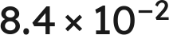 g and 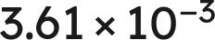 g. Find their difference. 1 pt
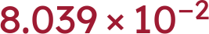 g
Match the powers first: , and 8.4 − 0.361 = 8.039.
Scoring: a 1 · b 1 = 2 points.

The Order of Operations with Exponents and Radicals 13 points MA.8.NSO.1.7
If an earlier part is wrong, a later part still earns its point when the right operation is applied to your own earlier answer — but only if that work is on the page.
9. Evaluate each expression.
a.  1 pt
8
The power first, then the product, then the subtraction.
b. 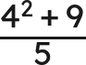 1 pt
5
25 over 5; the bar groups the whole numerator.
c. 45 ÷ 9 · 3 1 pt
15
One level, left to right: 5 · 3. Not 5.
d. 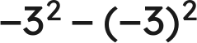 1 pt
−18
−9 − 9. The parentheses decide what the exponent is attached to.
Scoring: a 1 · b 1 · c 1 · d 1 = 4 points.

10. Evaluate each expression.
a. 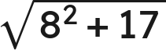 1 pt
9
Finish under the bar: 64 + 17 = 81.
b. 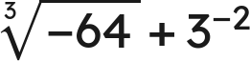 1 pt
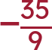
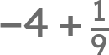.
c. 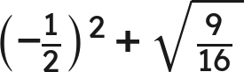 1 pt
1
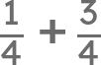.
Scoring: a 1 · b 1 · c 1 = 3 points.

11. A square patio of side 12 feet is sealed at 2.60 dollars a square foot, with a flat 75 dollars for delivery.
a. Write an expression for the total cost. 1 pt
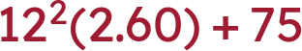
The rate multiplies the area; the flat fee does not. An expression that charges 75 on every square foot does not earn the point.
b. Find the total cost. 1 pt
449.40 dollars
144(2.60) = 374.40, then + 75.
Scoring: a 1 · b 1 = 2 points.

12. Which is the value of 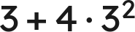 ? 1 pt
○ A. 27
○ B. 63
○ C. 225
● D. 39
D
Scoring: 1 point.

13. Select ALL of the expressions whose value is 8. 1 pt
☒ A. 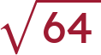
☐ B. 64 ÷ 4 · 2
☒ C. 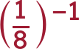
☐ D. 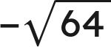
☒ E. 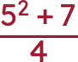
☒ F. 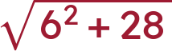
A, C, E and F
All four correct and nothing else for the point.
Scoring: 1 point.

14. Tomas writes . Explain why he is wrong, and give the correct value. 1 pt
The radical bar is a grouping symbol, so 36 + 64 is finished before the root is taken: . The root of a sum is not the sum of the roots.
The point needs the reason AND the value. '10' alone does not earn it, and neither does 'he added wrong'.
Scoring: 1 point.

15. A square tile has an area of 225 square inches. A second square tile has a side twice as long as the first. What is the area of the second tile? 1 pt
900 square inches
TRANSFER ITEM — not on the practice test. Same benchmark, a surface nobody rehearsed. The side of the first is 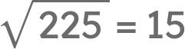, so the second has side 30 and area . Doubling a side and asking for the new area appears on no review and in no question bank; a student who doubles the area and writes 450 has not gone through the side.
Scoring: 1 point.

Score Tracker
Benchmark | Questions | Possible | Earned
MA.8.NSO.1.5 | 1, 2, 3, 4, 5, 6 | 12
MA.8.NSO.1.6 | 7, 8 | 4
MA.8.NSO.1.7 | 9, 10, 11, 12, 13, 14, 15 | 13
Total |  | 29

If an earlier part is wrong, a later part still earns its point when the right operation is applied to your own earlier answer — but only if that work is on the page. Nothing is weighed and nothing is arguable: apply the part's operation to the student's own earlier value and tick if that is what is written.

